Integration Tests Document

Project Title: Library Management System (LMS)
Project Type: Full-stack Web Development Capstone Project
Document Version: 1.0

Test# | Test Case | Expected Result | Test Result
IT-001 | Suspended member logs in | Not allowed to login | Passed  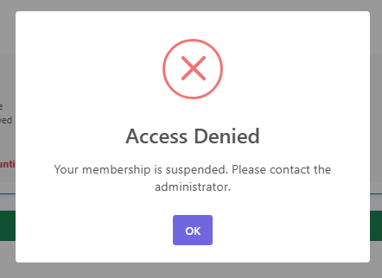
 | Member with past dues log in | Recieved past due notification | Passed  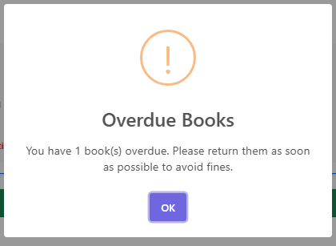
 | Member with expired membership logs in | Dialog open with choice to renew or cancel. | Passed    